Enterprise AI Data Analytics Portal
Algorithmic Data Flows — Diagram Pack
Low-level pipelines: chunking, embeddings, cosine similarity, dynamic pruning, FK expansion, and AST-based SQL validation.

1. RAG Ingestion — Turning Documents into Searchable Vectors
This happens ahead of time, whenever a new policy document is added to docs/.
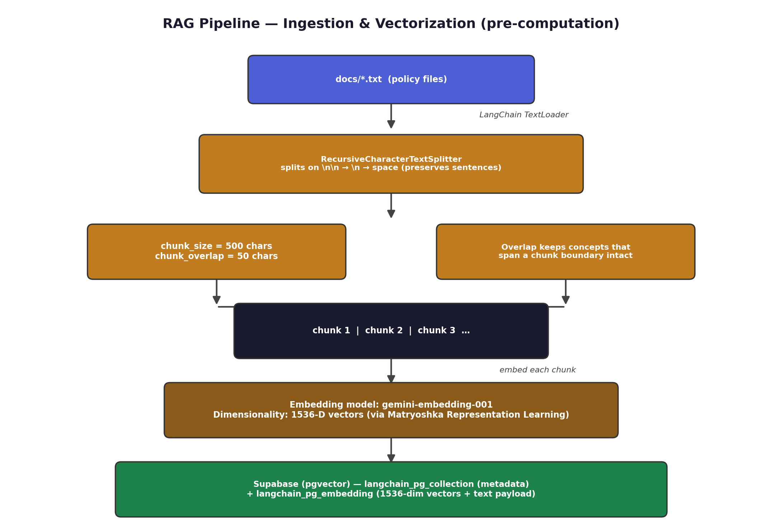
Figure 1 — Chunking and embedding pipeline for policy documents.
- Chunking: RecursiveCharacterTextSplitter tries \n\n (paragraphs) first, then \n, then spaces — so it never cuts a sentence in half.
- chunk_size = 500 characters, chunk_overlap = 50 characters, so a concept spanning a chunk boundary isn't lost.
- Each chunk is embedded with gemini-embedding-001 into a 1536-dimension vector, using Matryoshka Representation Learning (MRL) to truncate efficiently without losing much meaning.
- Vectors + text are stored in Supabase via pgvector, across two auto-created tables: langchain_pg_collection (metadata) and langchain_pg_embedding (vectors + payload).

2. RAG Retrieval — Answering a Policy Question at Runtime
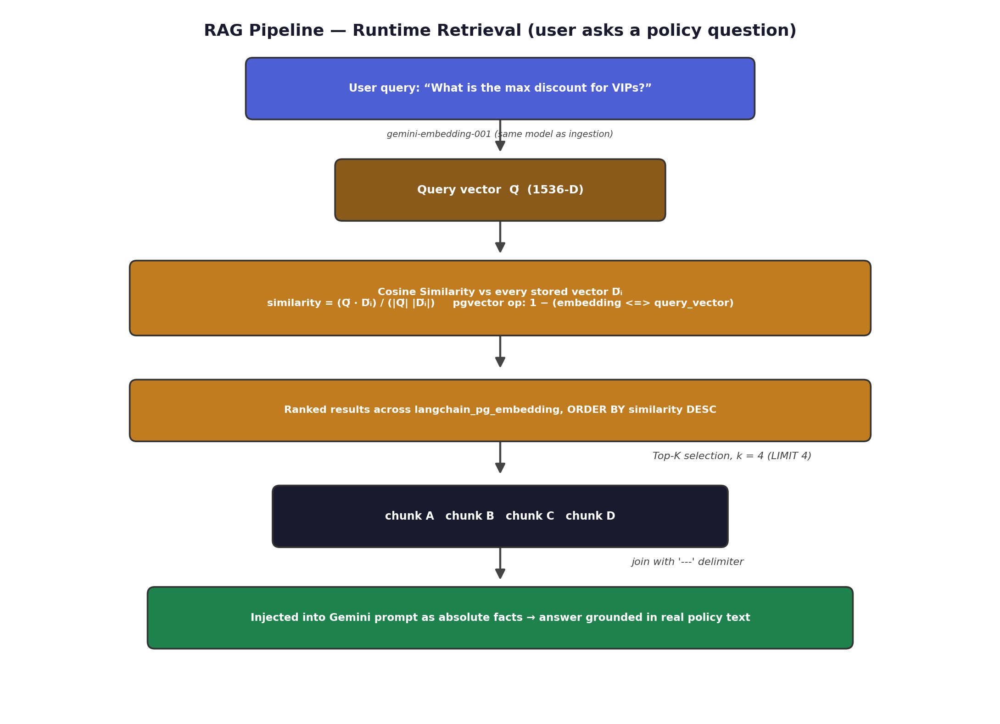
Figure 2 — Cosine-similarity retrieval when a user asks a policy question.
- The user's question is embedded with the same model into the same 1536-D space — call this vector Q⃗.
- Cosine similarity compares Q⃗ to every stored chunk vector D⃗ᵢ: similarity = (Q⃗·D⃗ᵢ) / (|Q⃗||D⃗ᵢ|).
- pgvector's <=> operator returns cosine distance, so the query computes 1 − (embedding <=> query_vector) to sort by similarity descending.
- Top-K = 4: only the 4 closest chunks are kept, joined with a '---' delimiter, and injected into the Gemini prompt as ground-truth facts.

3. Semantic Schema Retrieval — Picking the Right Tables
Solves “context window flooding”: an enterprise DB can have hundreds of tables, so the system must narrow down to a relevant handful before writing SQL.
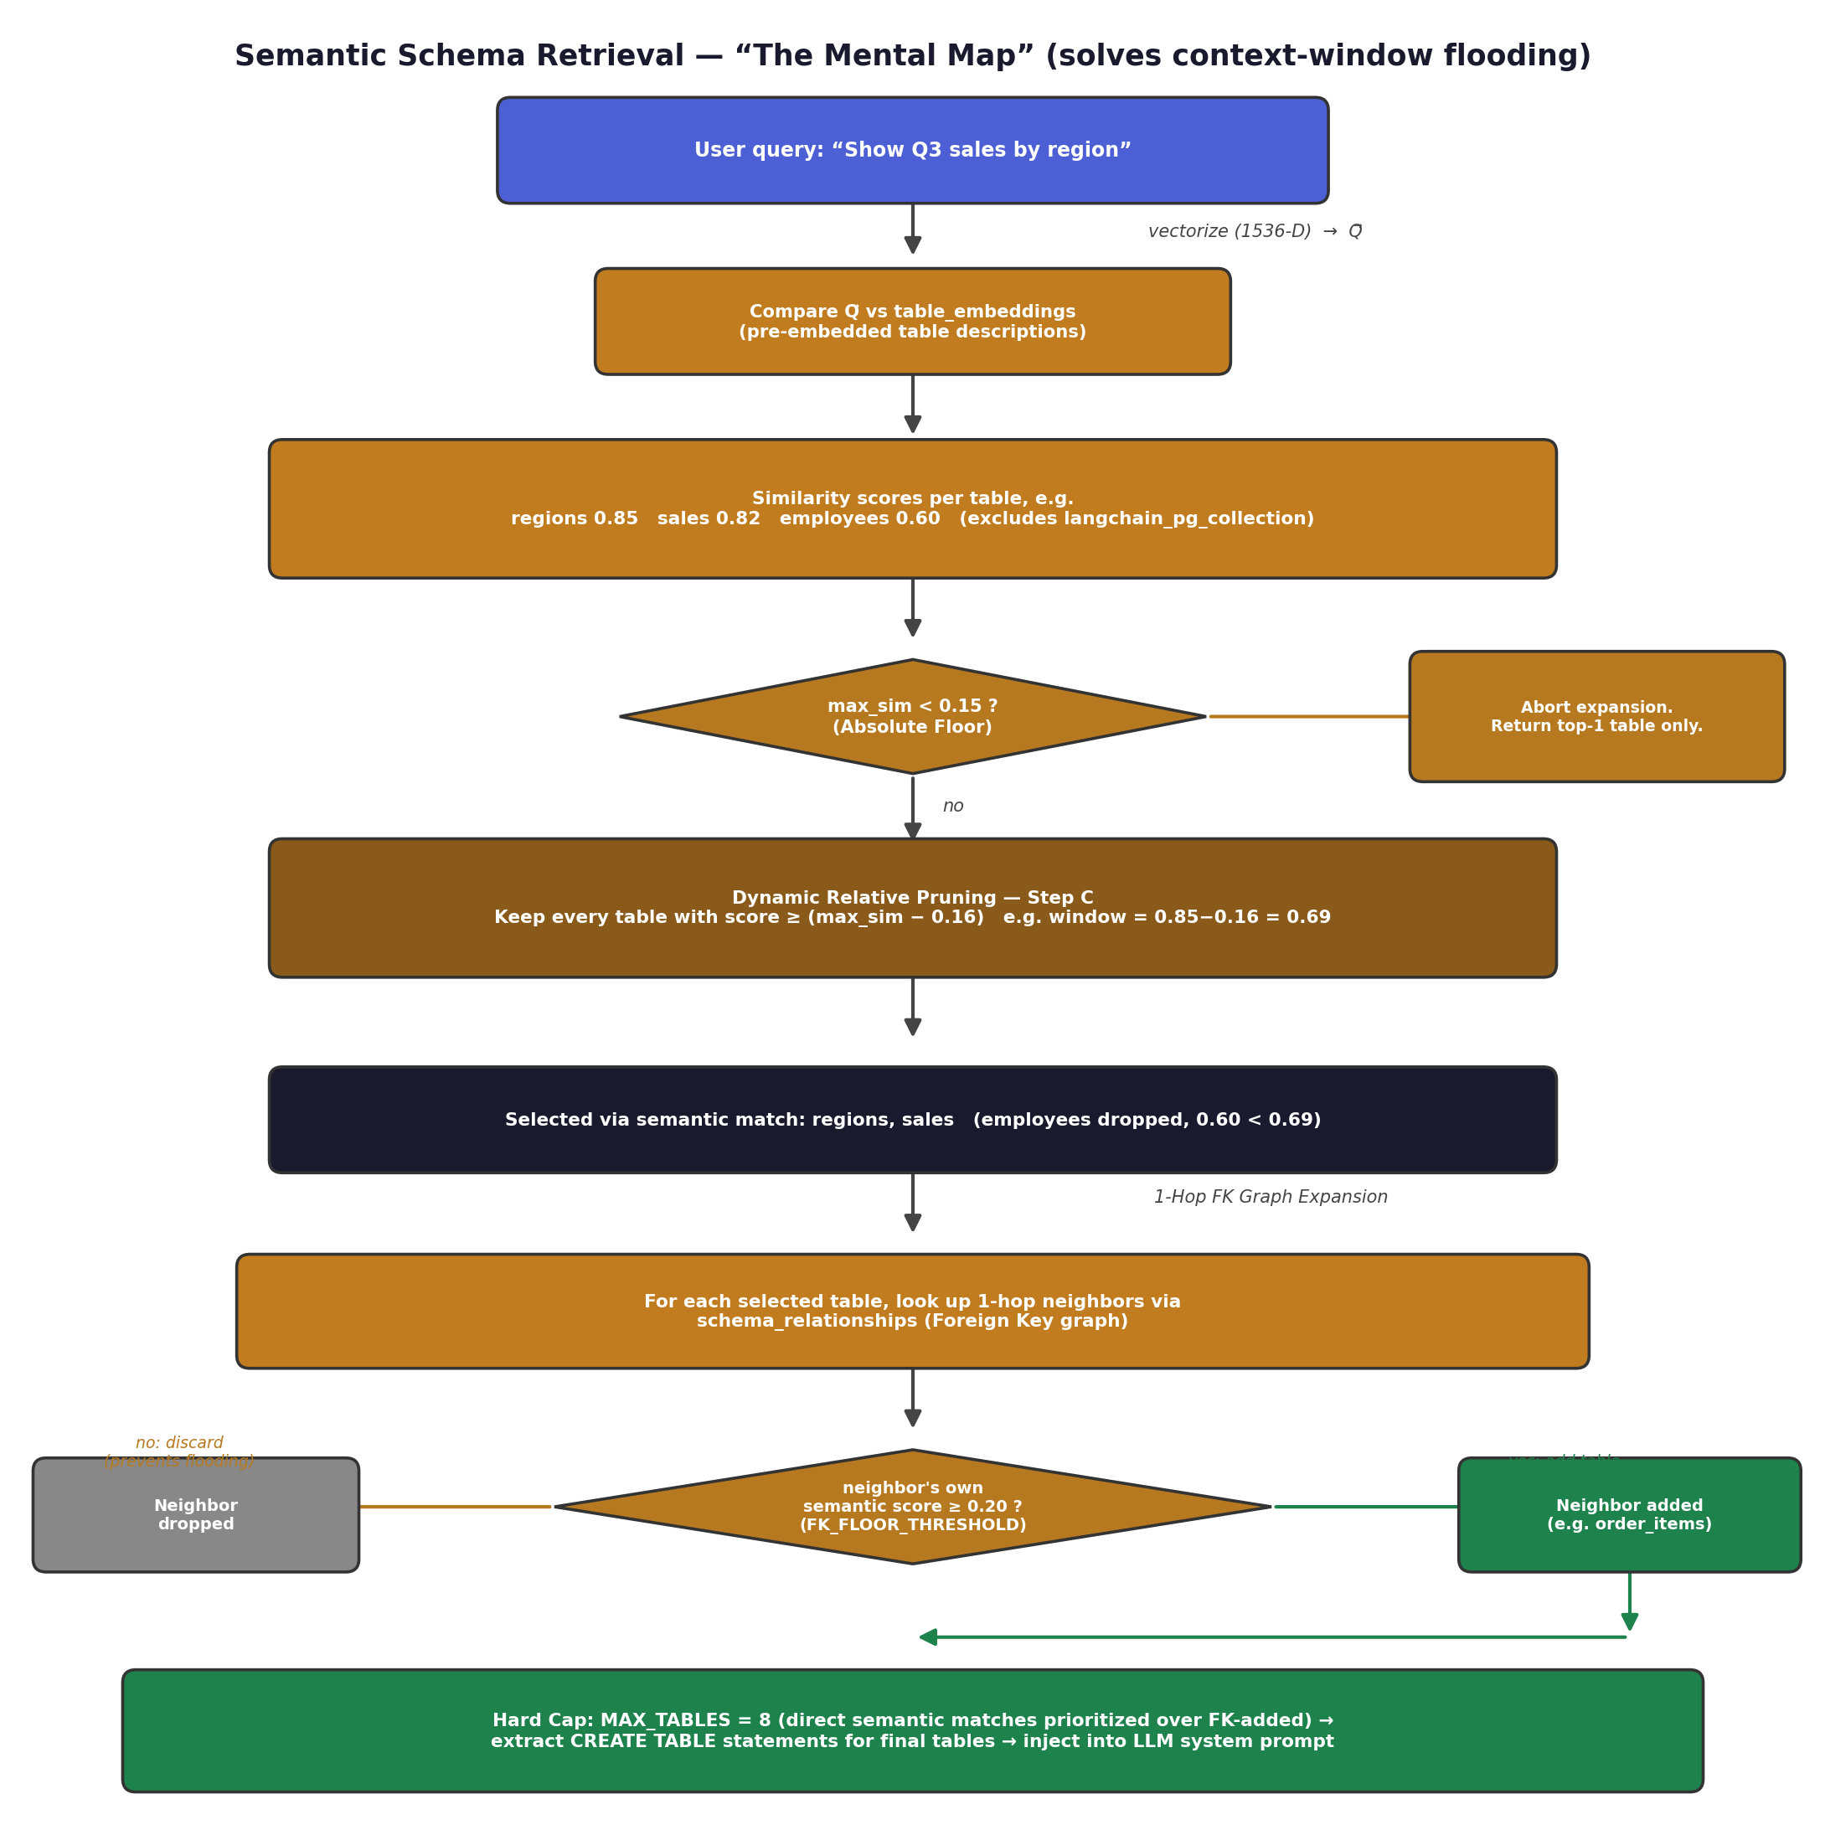
Figure 3 — Dynamic relative pruning and 1-hop FK expansion.

3.1 Dynamic Relative Pruning (the 0.16 delta rule)
- A fixed absolute cutoff (e.g. “keep everything above 0.6”) doesn't work well, because short vs. long queries produce very different baseline similarity scores.
- Absolute floor: if the single best-matching table scores below 0.15, the query is treated as noise and only that one table is returned.
- Relative window: otherwise, every table scoring within 0.16 of the top score is kept — e.g. a 0.85 top score keeps anything ≥ 0.69.

3.2 1-Hop Foreign Key Expansion
- Semantic search alone can miss “bridge” tables — e.g. asking about order totals may not mention order_items by name.
- For every semantically-selected table, its direct Foreign Key neighbors are considered for inclusion.
- FK_FLOOR_THRESHOLD = 0.20: a neighbor is only added if it already had at least some baseline semantic relevance (≥ 0.20) — otherwise a highly-connected table like users would drag in dozens of irrelevant tables.

3.3 Hard Capping
- The final table list is capped at MAX_TABLES = 8, with direct semantic matches prioritized over FK-expanded ones.
- CREATE TABLE statements for just those tables are extracted and inserted into the LLM's system prompt.

4. SQL Generation — AST Validation & Auto-Correction
Once the AI has its pruned schema, it writes SQL — which then has to be proven safe and correct before it ever touches the database.
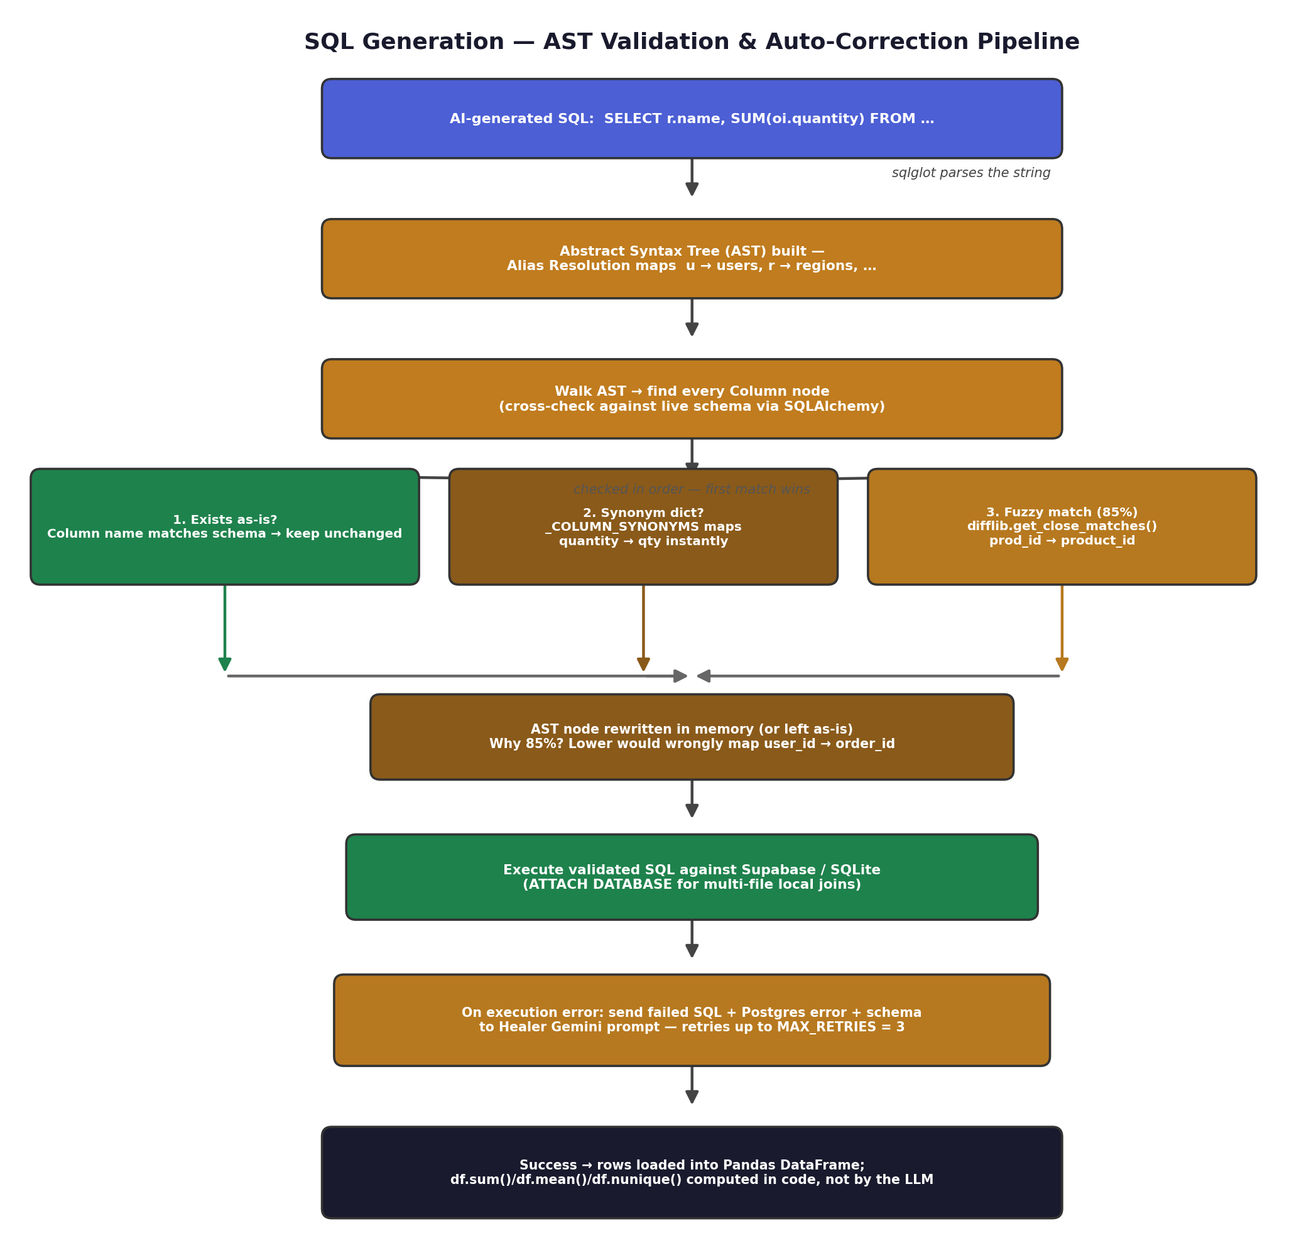
Figure 4 — AST parsing, three-lane column correction, and the healer retry loop.
- sqlglot parses the raw SQL string into an Abstract Syntax Tree (AST) and resolves aliases (e.g. “FROM users u” → u = users).
- Every Column node is checked, in order, against three lanes: (1) does it already match the real schema, (2) is it in the hardcoded _COLUMN_SYNONYMS dictionary (e.g. quantity → qty), (3) does difflib.get_close_matches() find an ≥85% fuzzy match (e.g. prod_id → product_id).
- 85% was chosen deliberately — a looser threshold risks silently mapping something like user_id to order_id, which would corrupt results instead of fixing them.
- If execution still fails after correction, the failed SQL, the Postgres error, and the schema are sent to a secondary “Healer” Gemini call, retried up to MAX_RETRIES = 3.
- On success, rows go into a Pandas DataFrame, and summary stats (sum, mean, nunique) are computed in code — never by the LLM — which is the basis of the zero-hallucination guarantee.

5. End-to-End Walkthrough
Tying every stage together with the concrete example from the spec: “Which region sold the most units?”
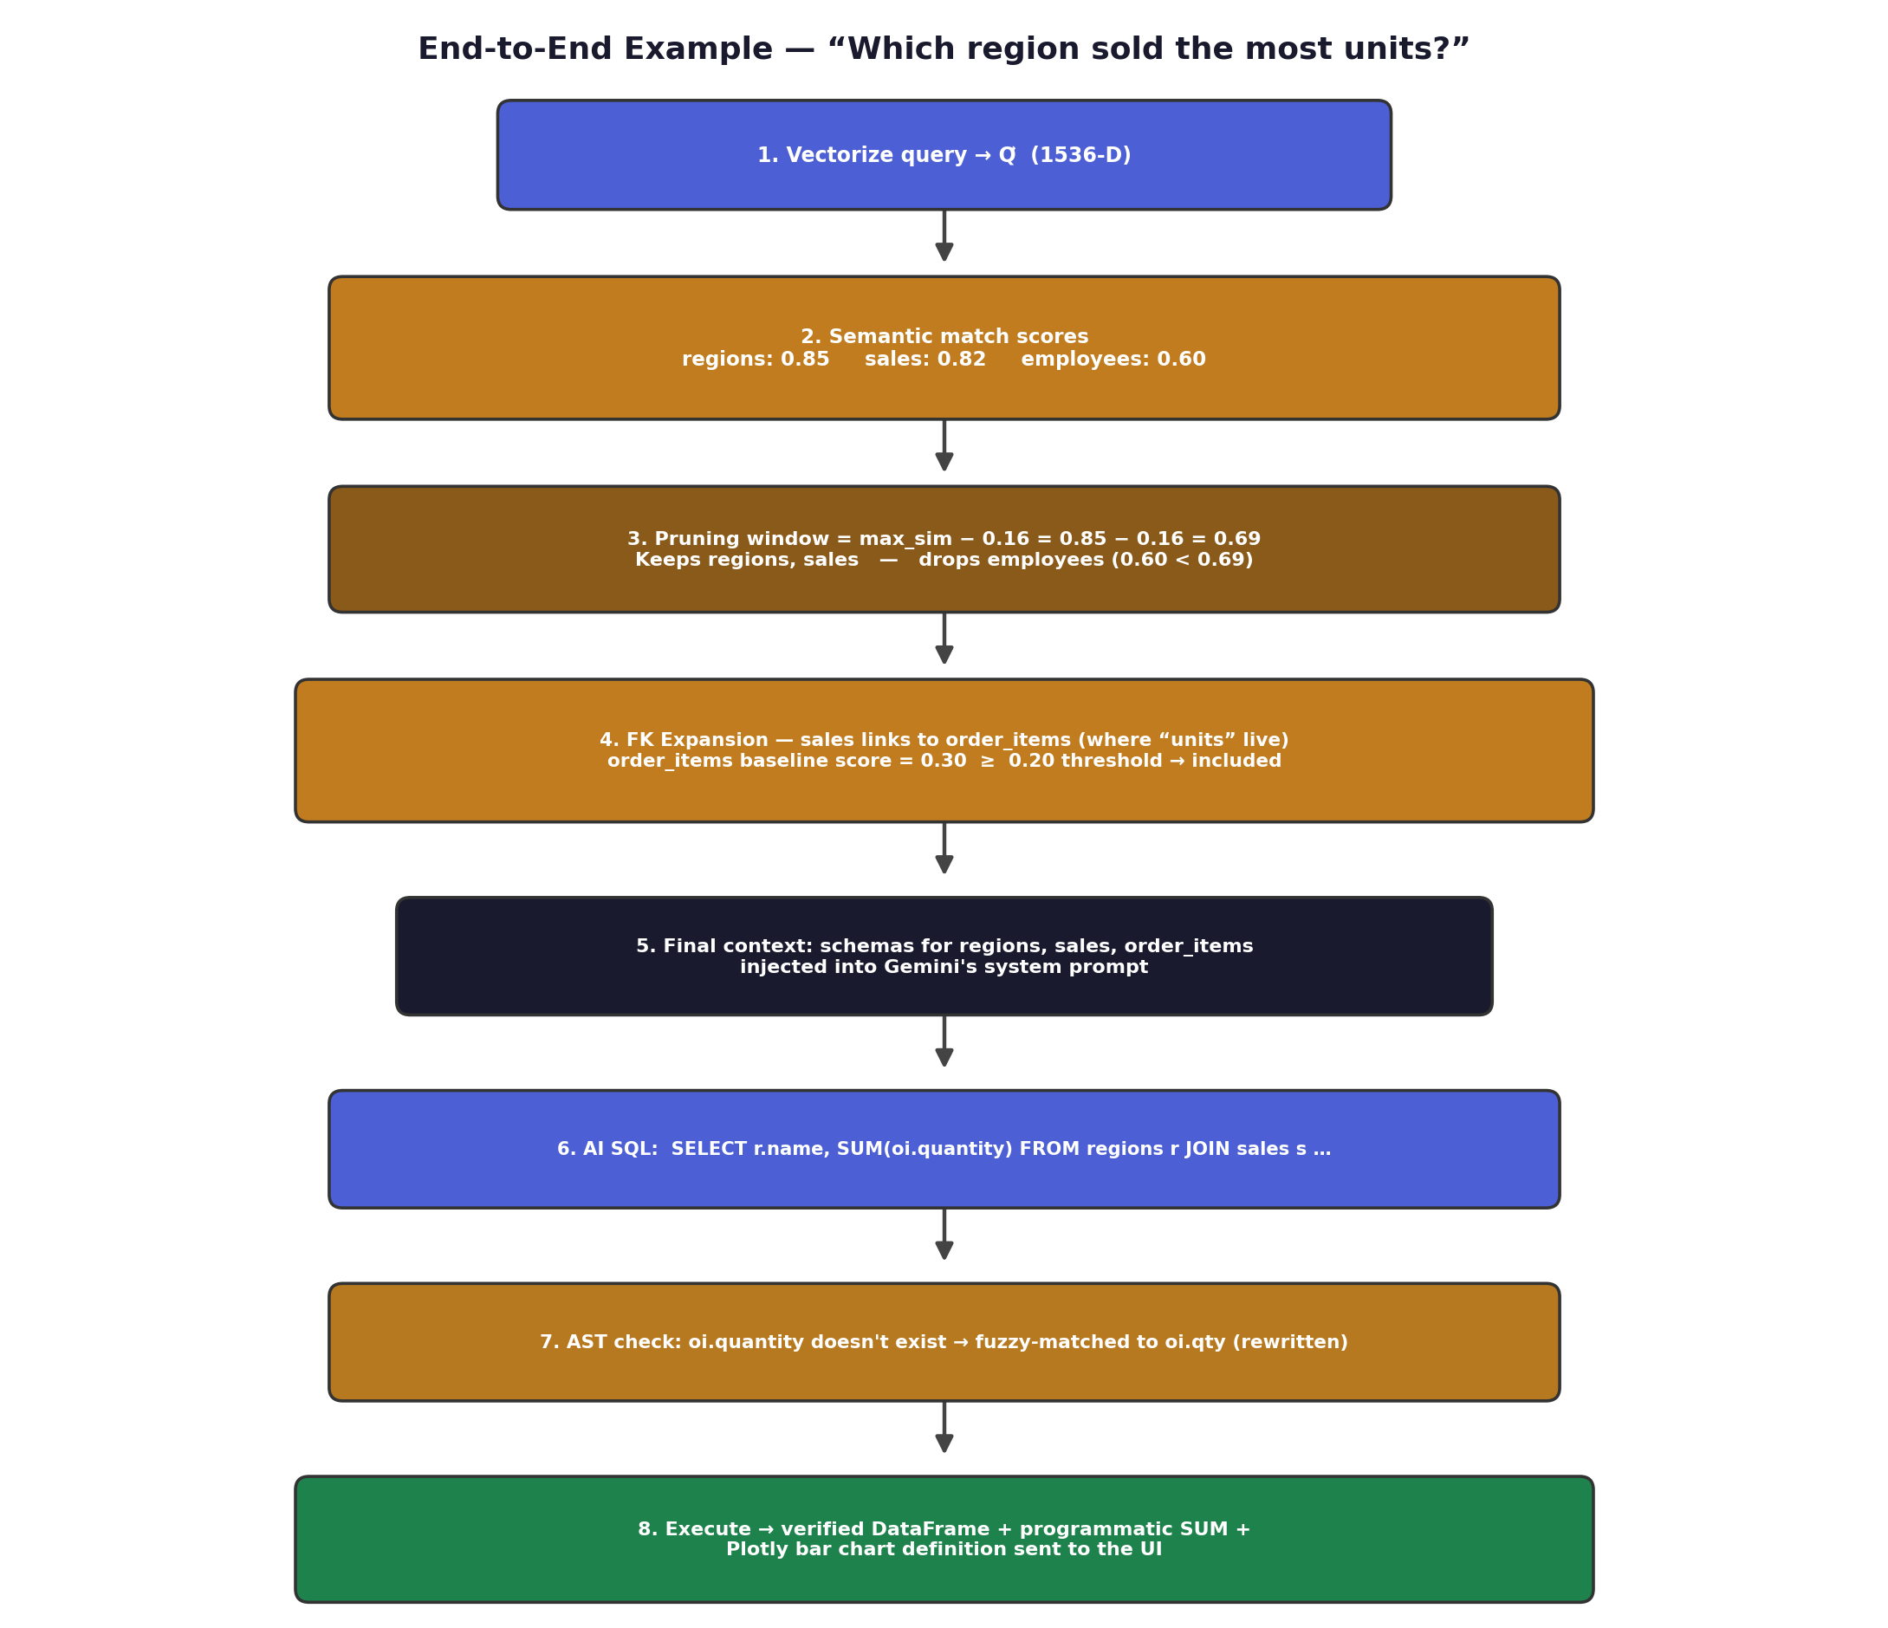
Figure 5 — A single query traced through table routing, SQL generation, and correction.
- Table routing picks regions (0.85) and sales (0.82) directly, drops employees (0.60, below the 0.69 window), then pulls in order_items via FK expansion because its own score (0.30) clears the 0.20 floor.
- The AI writes SQL referencing oi.quantity, which doesn't exist; fuzzy matching silently rewrites it to oi.qty before execution.
- The final payload to the frontend is the exact DataFrame, a programmatically computed sum, and a ready-to-render Plotly bar chart definition.

